Sean Gordon

CprE 431

Module 4 Lab

This lab focused on the slowloris attack, exploring its effects and some preventative methods and workarounds.

Initial resource allocation and slice:

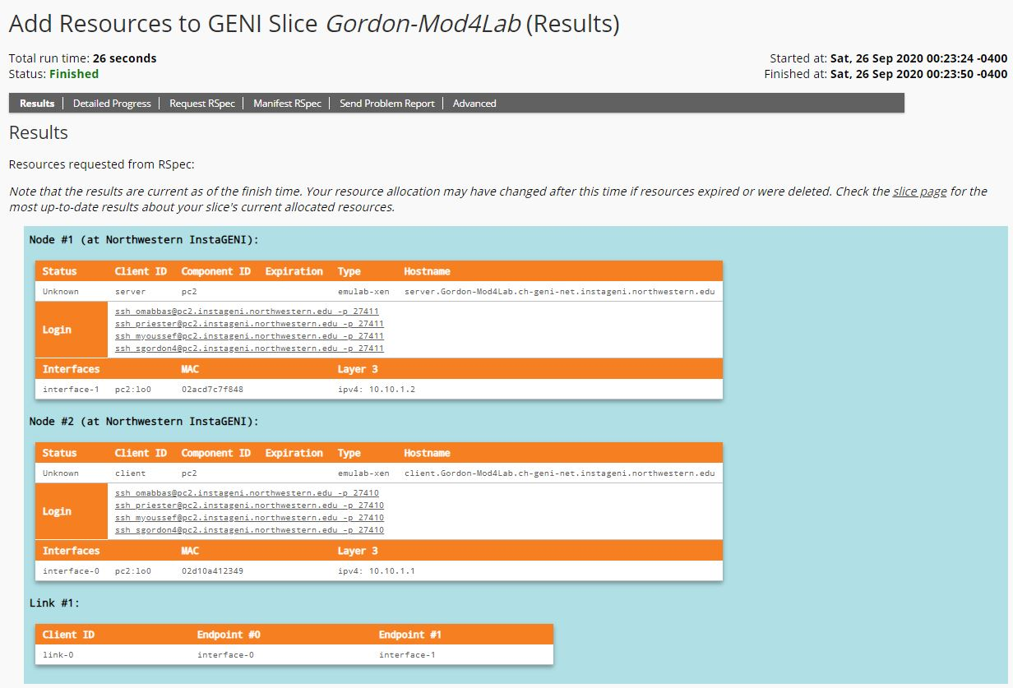

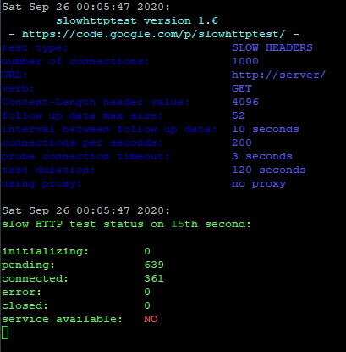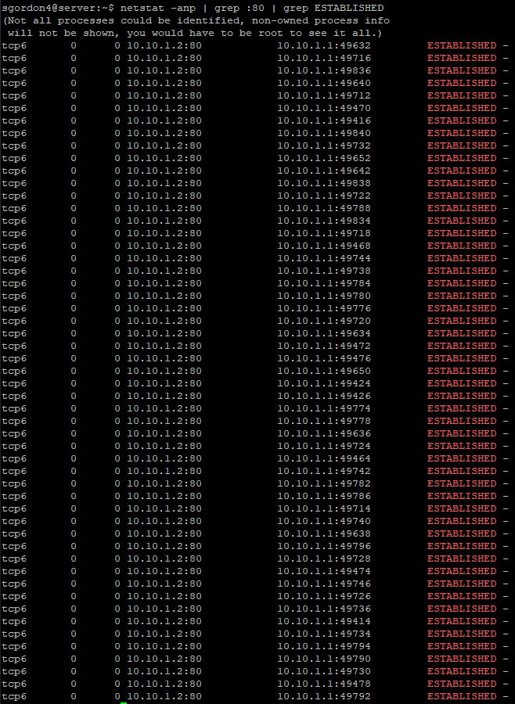First run of slowloris on an unprepared server:

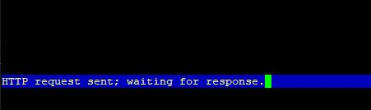

Second run of slowloris with limited bandwidth:

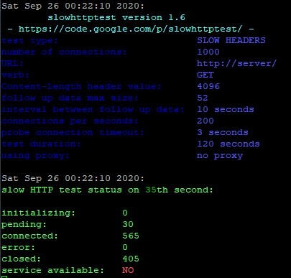

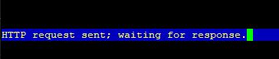

Third run of slowloris using firewall rules:

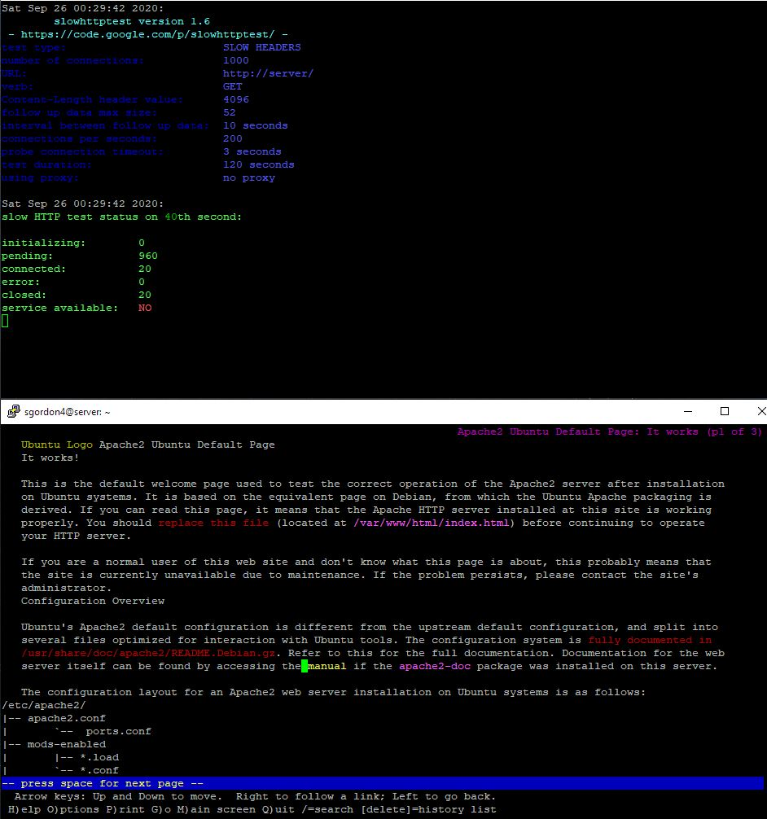

Fourth run of slowloris using a non-blocking server design:

